

**Web (MERN stack) and Mobile (Flutter) E commerce Site:**

A group project’s report submitted in partial fulfillment of the requirements for the course CSE-404: Software Engineering of Bachelor of Science in Computer Science and Engineering.

Course Name: Software Engineering

Course code: CSE 404

Submitted by: Fahmeda Gulzar (153014016)

Shamia Ferdousy(171014038)

Fatima- Tuz- Zohora Mithila(172014028)

Md. Solaiman Sunny (153014008)

Asif Iqbal (172014009)

Rahul Roy (172014022)

Md. Talha Jubayer (172014035)

Rupom Biswas (172014043)

**Declaration:**

This project report is submitted to Satyaki Das, faculty of University of Liberal Arts Bangladesh in partial fulfillment of the requirements for the course cse-404: Software Engineering of Bachelor of Science. So, we hereby, declare that this project report is based on the surveys found by us. Materials of work found by other researchers are mentioned by reference. This report, neither in whole, nor in part, has been previously submitted. For this project report, neither in whole, nor in part, has been previously submitted for any degree.

TABLE OF CONTENT

CHAPTER TITLE PAGE

Abstract 04

List of Symbols 04

Keywords 04

1. Introduction 05

2. Software Process 05

3. SDLC (Software Development Life Cycle) 06

4. Project Requirement list 06

5. Software Requirements Specification 07

5.1. Scenario-Based Model 07

5.2. Data-Based Model 11

6. Object Oriented Analysis and Design 17

6.1. Class-Based Model 17

7. Software Test Plans 32

7.1. Black Box Testing 32

8. Implementation 34

9. Future Goals 34

Abstract:

Nowadays, people are being dependent on technology. And everyone likes to shop online which is safe because of pandemic. So our idea was to develop an E-commerce website. To make it happened from the scratch of course we needed to follow a lot of steps which have learnt from the course (Software Engineering).

Keywords:

SDLC, E-commerce, website, model, based etc.

List of Symbols:

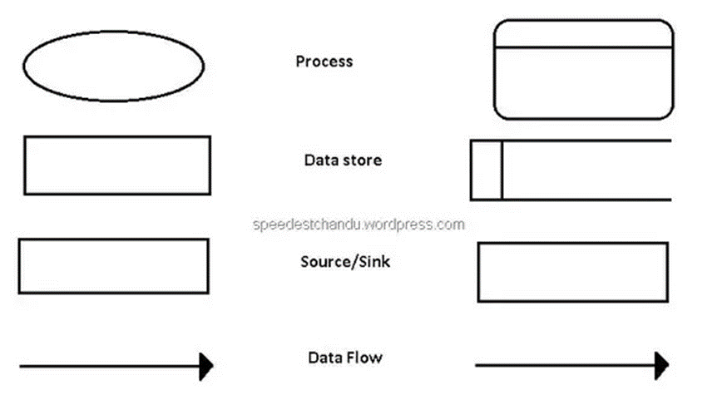

Introduction

An e-commerce website is an information technology method in which trader, businesses/distributor/marketers can sell products/services and the customer can purchase on that website electronically by using internet on the mobile and computer. So our focus is to make a website using MERN STACK for WEB and Flutter for mobile. The reason we selected MERN STACK is to move quickly, particularly for those with React.js experience. Like any web stack, we can build whatever we want in MERN - though it’s ideally suited for cases that are JSON-heavy, cloud-native, and that have dynamic web interfaces. And in Flutter we can change our code and see the results in real-time. It’s called Hot-Reload. It only takes a short amount of time after we save to update the application itself. And also easy to learn.

Software Process

Purpose of process is to deliver software in a timely manner and with sufficient quality to satisfy those who have sponsored its creation and those who will use it. So we followed Five Activities of a Generic Process framework which is:

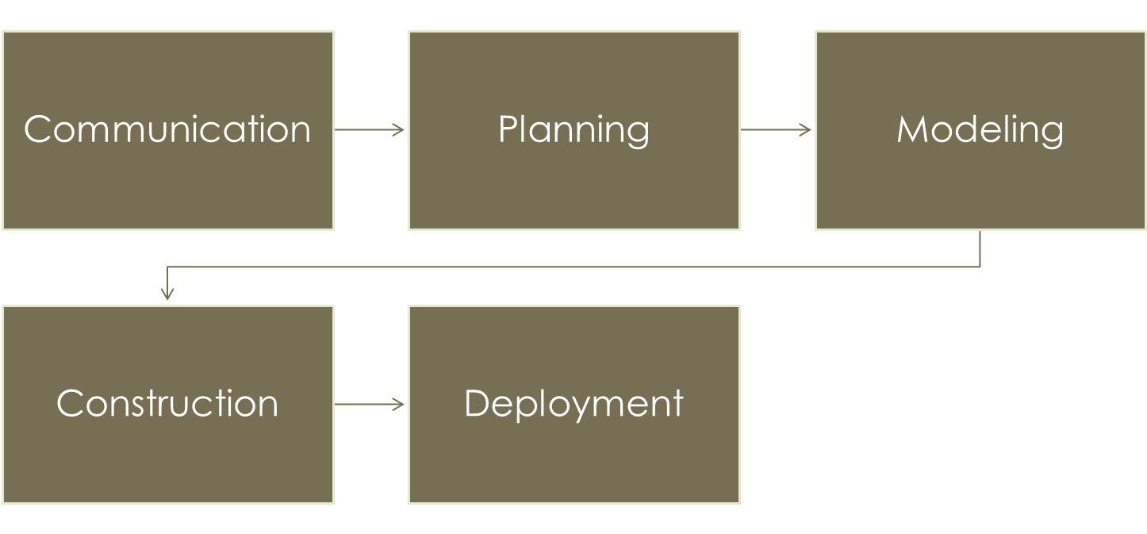

Software Development Life Cycle

It refers to a methodology with clearly defined processes for creating high-quality software. There are several SDLC model for example Linear Sequential Model/Waterfall Model, V-Model, Spiral Model, and Iterative Model. In this Project we have used Waterfall model.

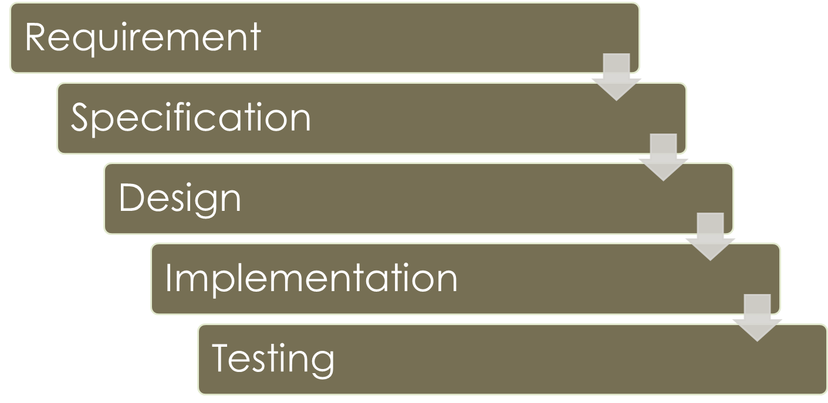

Diagram 1: Waterfall Model

Project Requirement List

We have been given a Project requirement list which is given below:

Software Requirements Specification

Scenario-Based Modeling

Data-Based Modeling

Object Oriented Analysis and Design

Class-Based Modeling

Software Test Plans

Black-Box Testing, White Box Testing (if needed)

Presentable Demo of Software

Showcase the first iteration of your software (incremental/evolutionary)

Software Requirements Specification

It includes a variety of elements (see below) that attempts to define the intended functionality required by the customer to satisfy their different users. Mainly 4 Types of Requirements Analysis Models:

Scenario Based Models

Data Based Models

Class Based Models

Behavioral Models.

Scenario Based Model

3 Types of modelling should be specified:

Usage Scenario:

The E-commerce site has two types of users. One is the Consumer and the other is the Admin. The usage scenario can be divided into small modules for better understanding according to their roles.

The Register and Sign-in: The first thing a consumer will see going into the website is the register and sign-in page. Here the consumer can register and create a profile providing his/her name, email-address, password, and finally confirming the password.

Home Page: After the profile is created, the consumer can see the home page. There will be a search bar where he can search for the desired product with its name and brand. When any search is done, the website will show the most popular products. Apart from that, the home page also contains a portion that displays different types of products along with its picture, name, brand, price and other specifications.

Product Page: The product page is displayed when the consumer clicks on any product. This page contains the title of the product, its description, and price. After that a portion of the page displays if the product is available or it is out of stock. Then it shows the option of quantity from where the consumer can select the number of products he wants. This page also shows the review of the product from the customer. Finally, there is an option to add the product to the consumer’s cart.

Shopping Cart: The shopping cart page mainly displays the list of the products that have been added to the cart by the consumer. It specifically displays the product image, its name, price, quantity, the subtotal, and finally the options from where the consumer can delete the product from the cart or select the “proceed to check out” option to place the order.

Shipping Page: The shipping page contains options where the consumer has to enter his address, city, and country. Mainly, the detailed address of the consumer where the product will be shipped. Here the consumer will have blank space for entering the address, for example, the house, block, and road number. The second option is of the city, the consumer can click his city from the suggestion list. Finally, he will click on the country from the suggestion list.

Payment: When a consumer proceeds to check out, he will see the payment options. There are three different payment options. He can select any of the payment options that he wishes among the Bkash system, Credit/Debit Card System, and pay by cash. If he selects the Bkash system, he will have to enter his bkash number in it after that. Then he has to confirm the number, and the system will deduct the amount from his Bkash account and send a notification to the consumer as soon as the payment is done. If he selects the Card option, he will have to enter the account number and confirm it. Then the system will deduct the amount from his account and send a notification as the confirmation of payment is done. If he selects pay by cash, then he can pay the amount when he receives the product and pay by cash.

Order Summary Page: This page contains different types of order related information. Such as, the shipping Information, payment information, ordered items information and placed order option. When the Consumer will click on the shipping option, he will be able to see the information about the shippings. If he clicks on the payment option, he will see information about the payment done so far, their methods and other details. If he clicks on the ordered items option, it will display him the list of the items he has ordered so far. If he clicks on the placed order option, he will see the order details of the products that he has added in the cart, and those can place the order.

Place Order: This module contains the checkout process, which is providing the shipping details and then selecting the payment method from the given options.

Consumer: The user module contains the profile of the consumer. There is consumer information (name, email address) that was provided by the consumer while creating the account. Then there is an option to check the order list of each item. Each order list contains ID, date, total cost, paid, and the delivered details.

Admin: The admin module has a number of responsibilities to supervise the system. The admin takes care of the product management, and the consumer management. In the user management, he can check the name of the consumer, his email, order list and other details. He can also prepare and display the order details to the consumers. After each payment is done, he can mark on the consumer's account as paid. He can also create a product by adding the name, price, image, brand and other specifications of the product, stock products and categorize the products.

Activity Diagram:

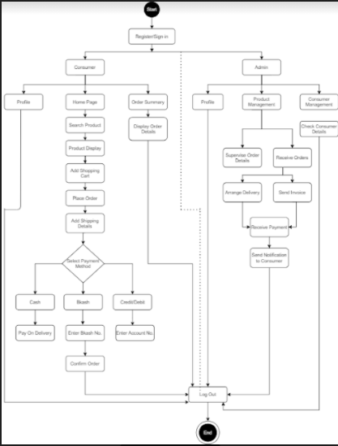

Use case diagram:

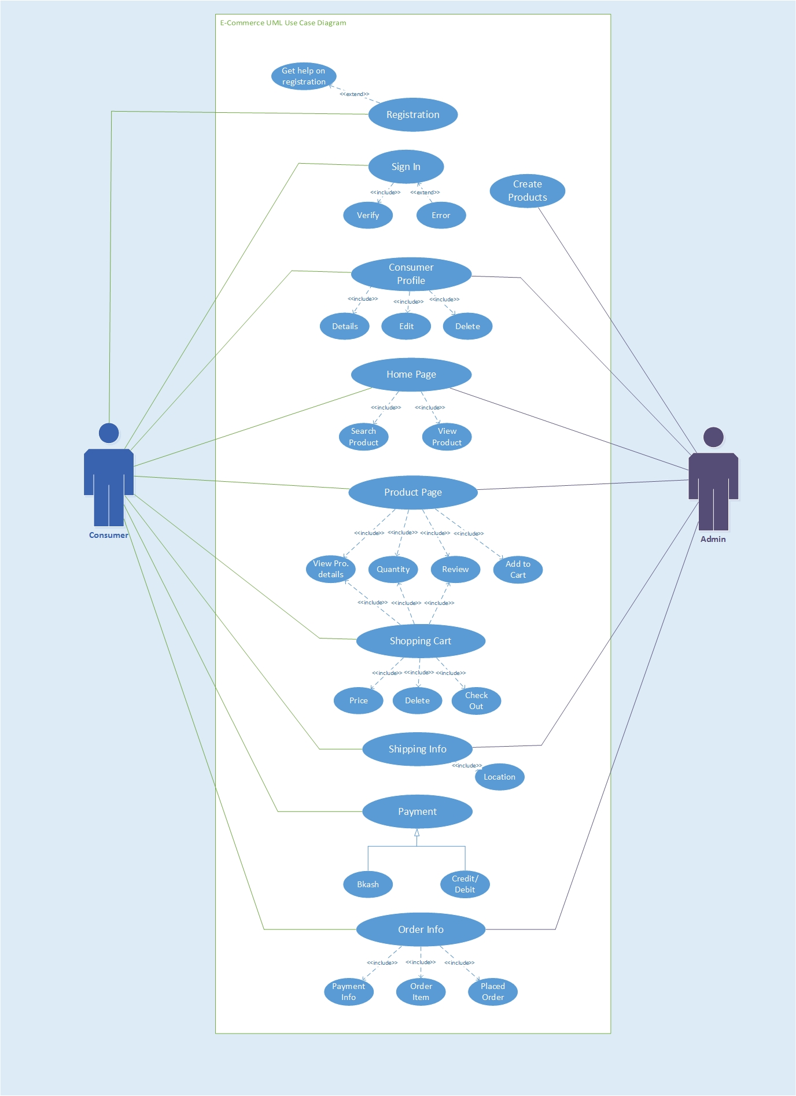

Level One DFD:

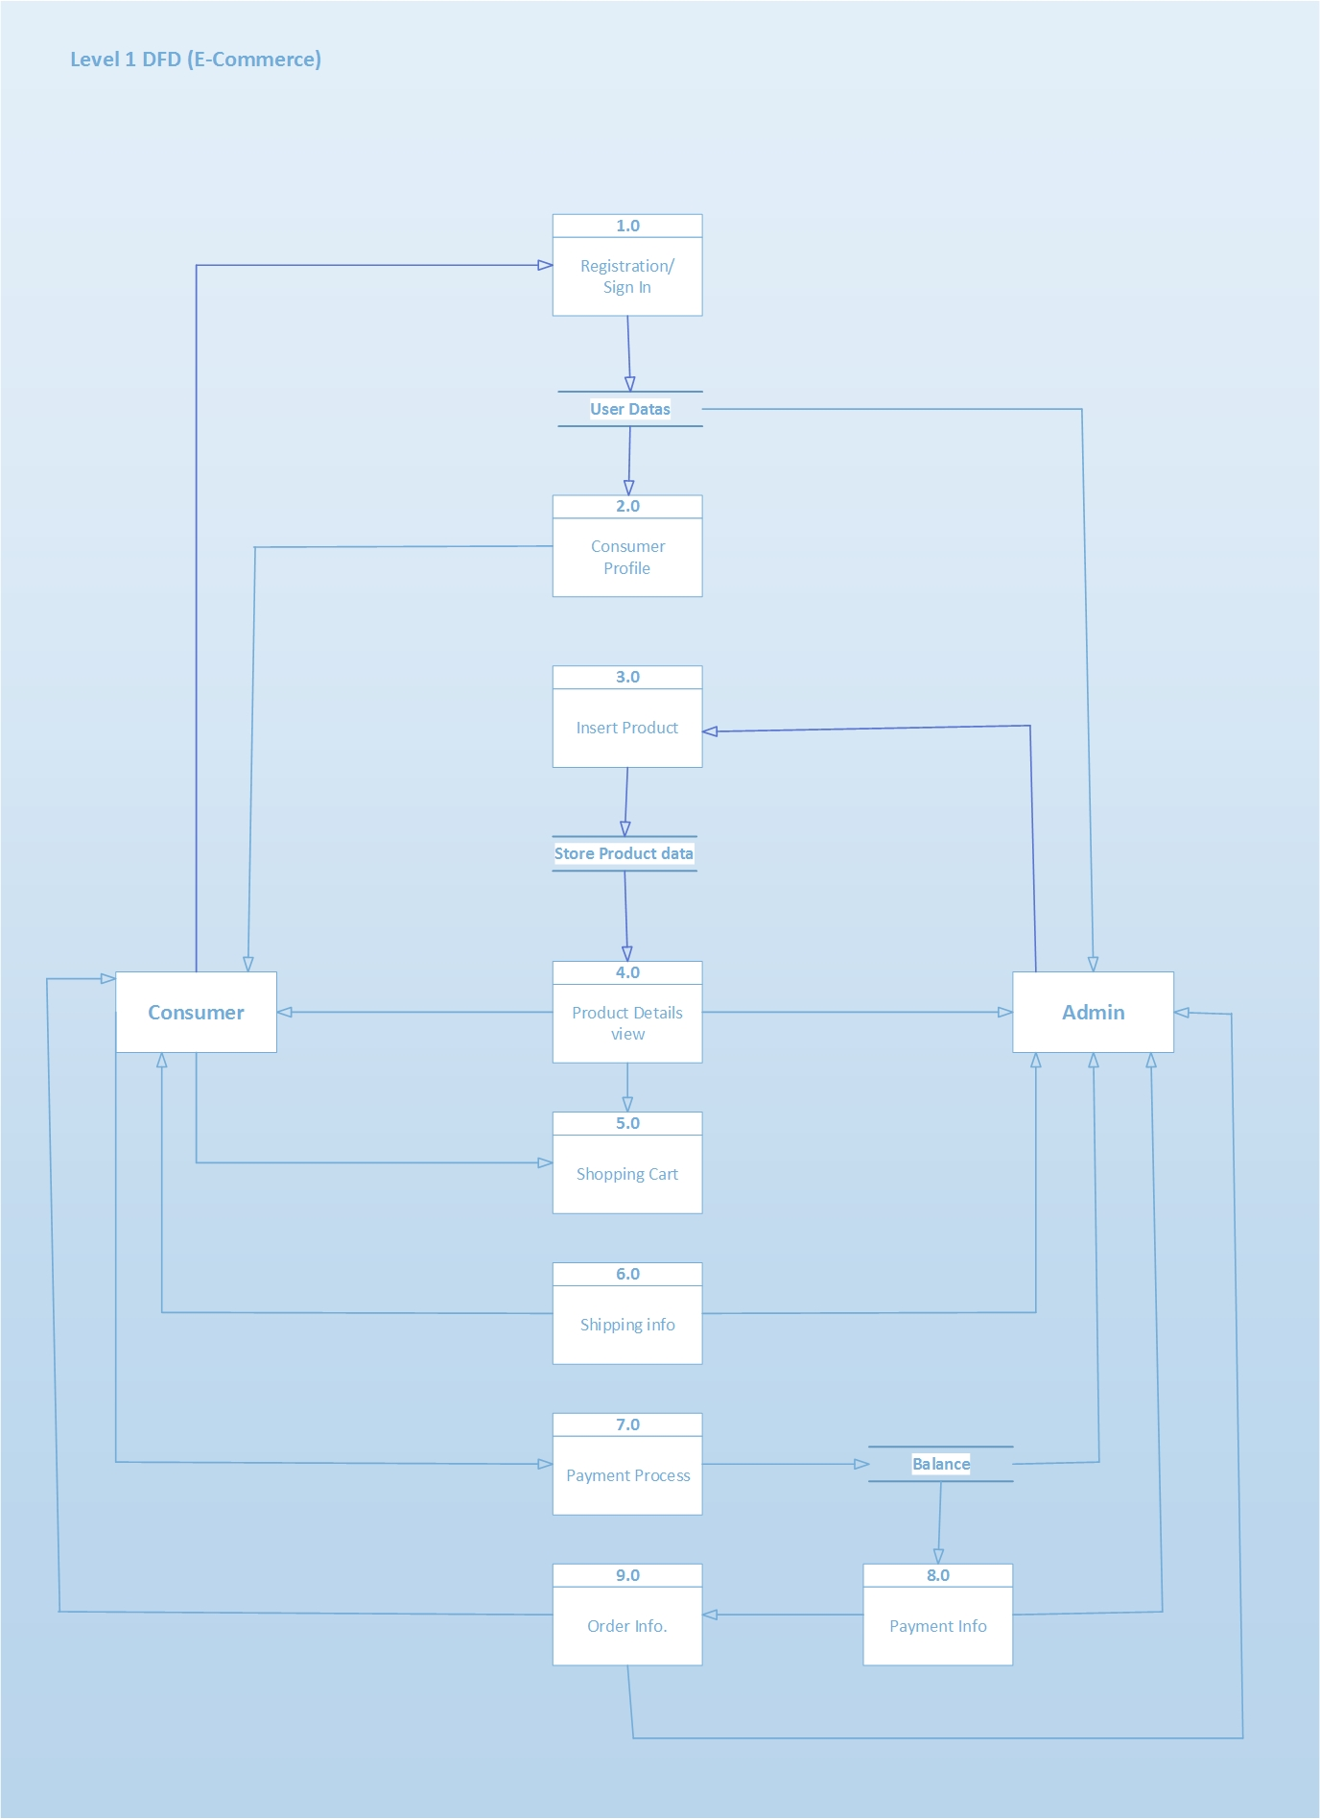

Data-Based Model:

By using the usage scenario Data-based model has been created which is described below

Noun Identification

|  |  |  |  |
| --- | --- | --- | --- |
| **ID** | **Noun** | **P/S** | **Attributes** |
|  | E commerce | P |  |
|  | User | S | 71 |
|  | Consumers | S | 71 |
|  | Admin | S | 71 |
|  | Website | S | 6,19,22,25,31,58,59,60 |
|  | Home page | S | 7,10,12 |
|  | Create a profile | S |  |
|  | Name | S |  |
|  | Email Address | S |  |
|  | Search bar | S |  |
|  | Search | S |  |
|  | Product | S | 18,19,29 |
|  | Product name | S |  |
|  | Product Brand | S |  |
|  | Popular Products | S |  |
|  | Display | P |  |
|  | Picture | S |  |
|  | Other specifications | S |  |
|  | Product page | S | 20,21,22,25 |
|  | Title of the Product | S |  |
|  | Description | S |  |
|  | Price | S |  |
|  | Quantity | S |  |
|  | Number of Products | S |  |
|  | Review of the Product | S |  |
|  | Add the Product | S |  |
|  | Consumer’s cart | S |  |
|  | Shopping Cart | S |  |
|  | List of the Products | S | 13,14,15,17,18 |
|  | Cart | S |  |
|  | Subtotal | S |  |
|  | Delete the Product | S |  |
|  | Place the Order | S |  |
|  | Shipping Page | S |  |
|  | Address | S |  |
|  | City | S |  |
|  | Country | S |  |
|  | House | S |  |
|  | Block | S |  |
|  | Road Number | S |  |
|  | Suggestion List | S | 22,29 |
|  | Check Out | S |  |
|  | Payment | S | 45,47,71 |
|  | Bkash | S |  |
|  | Credit/Debit Card Number | S | 51,53 |
|  | Cash | P |  |
|  | Bkash Number | S | 51,53 |
|  | Confirm the Number | S |  |
|  | Deduct the Amount | S |  |
|  | Notification | S |  |
|  | Account Number | S | 71 |
|  | Confirm | S |  |
|  | Amount | S |  |
|  | Receive the Product | S |  |
|  | Page | S |  |
|  | Order | S |  |
|  | Information | S |  |
|  | Shipping Information | S |  |
|  | Payment Information | S |  |
|  | Ordered Items Information | S |  |
|  | Placed Order | S |  |
|  | Shipping | S |  |
|  | Methods | P |  |
|  | Other Details | S |  |
|  | Ordered Items | S |  |
|  | List of the Items | S |  |
|  | Placed Order | S |  |
|  | Order Details of the Product | S |  |
|  | Module | P |  |
|  | Check out | S |  |
|  | Profile | S | 8,9,44,47,51,72,75 |
|  | Id | S | 8,9,72,75 |
|  | Total cost | S |  |
|  | Delivered Details | S |  |
|  | Number | S |  |
|  | Responsibilities | P |  |
|  | Supervise | P |  |
|  | Product Management | S |  |
|  | Consumer Management | S |  |
|  | Create a Product | S |  |
|  | Stock Products | S |  |
|  | Categorized the Product | S |  |

Data Base Modeling

Website**:** Home page, Product page, Price, Review of the Product, Subtotal, Shipping Information, Payment Information, Ordered Items Information

Home page**:** Create a profile, Search bar, Product

Product**:**  Product page, List of the Product.

Product page:Title of the Product, Description, Price, Review of the Product.

List of the Products**:** Product name, Product Brand, Popular Products, Other specifications.

Suggestion List: Price, List of the Products.

Payment:Credit/Debit Card Number, Bkash Number, Profile.

Credit/Debit Card Number**:** Account Number, Amount.

Bkash Number**:** Account Number, Amount.

Profile**:** Name, Email Address, Credit/Debit Card Number,Bkash Number, Account Number, Id, Number .

Id**:** Name, Email Address, Account Number, Number.

ER diagram

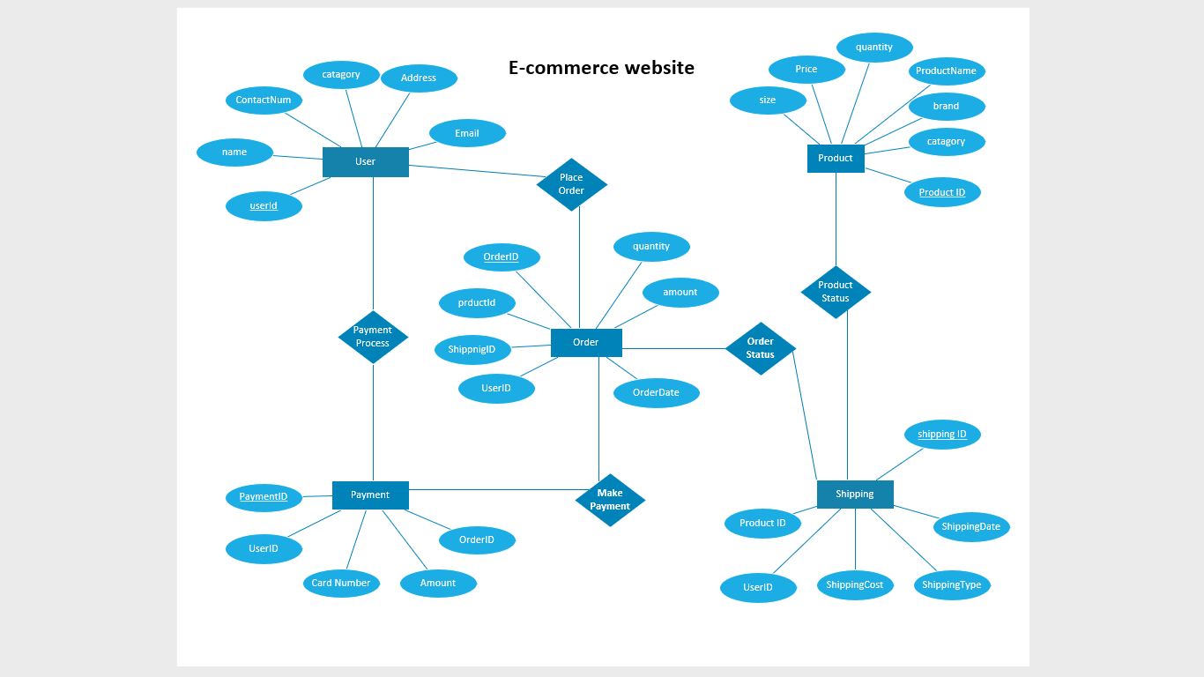

Schema Table

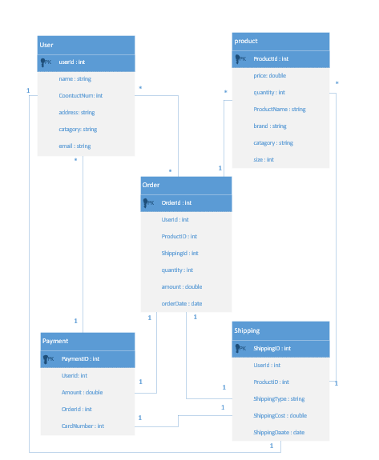

Object Oriented Design and Analysis

After designing the prototype of database by following the steps of databased model we have done object oriented designing by describing Class-based Model.

Class-Based Model

General Classification

External Entities (e.g., other systems, devices, people) that produce or consume information to be used by a computer-based system.

Things (e.g., reports, displays, letters, signals) that are part of the information domain for the problem.

Occurrence or events (e.g., a property transfer or the completion of a series of robot movements) that occur within the context of system operation.

Roles (e.g., manager, engineer, salesperson) played by people who interact with the system.

Organizational units (e.g., division, group, and team) that are relevant to an application.

Places (e.g., manufacturing floor or loading dock) that establish the context of the problem and the overall function of the system. Structure (e.g., sensors, four-wheeled vehicles, or computers) that define a class of objects or related classes of objects.

|  |  |  |  |  |  |  |  |  |  |
| --- | --- | --- | --- | --- | --- | --- | --- | --- | --- |
| ID | Noun | General Classification | | | | | | | Remarks |
| External | Things | Events | Roles | Units | Places | Structure |
|  | E-commerce | **×** | **×** | **×** | **×** | **×** | **×** | ✓ | ✓ |
|  | sign-in page | **×** | ✓ | **×** | **×** | **×** | **×** | ✓ | ✓ |
|  | User | **×** | **×** | **×** | ✓ | **×** | **×** | **×** | ✓ |
|  | Consumers | **×** | **×** | **×** | ✓ | **×** | **×** | **×** | ✓ |
|  | Admin | **×** | **×** | **×** | ✓ | **×** | **×** | **×** | ✓ |
|  | Website | **×** | **×** | **×** | **×** | **×** | **×** | ✓ |  |
|  | **Home page** | **×** | **×** | **×** | **×** | **×** | **×** | ✓ | ✓ |
|  | password | **×** | **×** | **×** | **×** | **×** | **×** | **×** |  |
|  | Name | **×** | **×** | **×** | **×** | **×** | **×** | **×** |  |
|  | Email Address | **×** | **×** | **×** | **×** | **×** | **×** | **×** |  |
|  | Profile | **×** | **×** | **×** | **×** | **×** | **×** | ✓ | ✓ |
|  | Search bar | **×** | **×** | **×** | **×** | **×** | **×** | ✓ | ✓ |
|  | Product | **×** | ✓ | **×** | **×** | **×** | **×** | **×** | ✓ |
|  | Product name | **×** | ✓ | **×** | **×** | **×** | **×** | **×** | ✓ |
|  | Product Brand | **×** | ✓ | **×** | **×** | **×** | **×** | **×** | ✓ |
|  | Popular Products | **×** | ✓ | **×** | **×** | **×** | **×** | **×** | ✓ |
|  | Display | **×** | ✓ | **×** | **×** | **×** | **×** | **×** | ✓ |
|  | Picture | **×** | ✓ | **×** | **×** | **×** | **×** | **×** | ✓ |
|  | Other specifications | **×** | ✓ | **×** | **×** | **×** | **×** | **×** | ✓ |
|  | **Product page** | **×** | **×** | **×** | **×** | **×** | **×** | ✓ | ✓ |
|  | Title of the Product | **×** | ✓ | **×** | **×** | **×** | **×** | **×** | ✓ |
|  | Description | **×** | ✓ | **×** | **×** | **×** | **×** | **×** | ✓ |
|  | Price | **×** | **×** | **×** | **×** | **×** | **×** | **×** |  |
|  | Quantity | **×** | **×** | **×** | **×** | **×** | **×** | **×** |  |
|  | Number of Products | **×** | **×** | **×** | **×** | **×** | **×** | **×** |  |
|  | Review of the Product | **×** | ✓ | **×** | **×** | **×** | **×** | **×** | ✓ |
|  | Consumer’s cart | **×** | ✓ | **×** | **×** | **×** | **×** | ✓ | ✓ |
|  | **Shopping Cart** | **×** | **×** | **×** | **×** | **×** | **×** | ✓ | ✓ |
|  | List of the Products | **×** | ✓ | **×** | **×** | **×** | **×** | **×** | ✓ |
|  | Cart | **×** | ✓ | **×** | **×** | **×** | **×** | **×** | ✓ |
|  | Subtotal | **×** | **×** | **×** | **×** | **×** | **×** | **×** |  |
|  | **Shipping Page** | **×** | **×** | **×** | **×** | **×** | **×** | ✓ | ✓ |
|  | Address | **×** | **×** | **×** | **×** | **×** | **×** | **×** |  |
|  | City | **×** | **×** | **×** | **×** | **×** | **×** | **×** |  |
|  | Country | **×** | **×** | **×** | **×** | **×** | **×** | **×** |  |
|  | House | **×** | **×** | **×** | **×** | **×** | **×** | **×** |  |
|  | Block | **×** | **×** | **×** | **×** | **×** | **×** | **×** |  |
|  | Road Number | **×** | **×** | **×** | **×** | **×** | **×** | **×** |  |
|  | Suggestion List | **×** | ✓ | **×** | **×** | **×** | **×** | **×** | ✓ |
|  | **Payment** | **×** | **×** | **×** | **×** | **×** | **×** | ✓ | ✓ |
|  | Bkash | ✓ | **×** | **×** | **×** | **×** | **×** | **×** | ✓ |
|  | Credit/DebitCard Number | **×** | **×** | **×** | **×** | **×** | **×** | **×** |  |
|  | Cash | **×** | ✓ | **×** | **×** | **×** | **×** | **×** | ✓ |
|  | Bkash Number | **×** | **×** | **×** | **×** | **×** | **×** | **×** |  |
|  | Notification | **×** | ✓ | **×** | **×** | **×** | **×** | **×** | ✓ |
|  | Account Number | **×** | **×** | **×** | **×** | **×** | **×** | **×** |  |
|  | Amount | **×** | **×** | **×** | **×** | **×** | **×** | **×** |  |
|  | **Page** | **×** | **×** | **×** | **×** | **×** | **×** | ✓ | ✓ |
|  | Information | **×** | ✓ | **×** | **×** | **×** | **×** | **×** | ✓ |
|  | Shipping Information | **×** | ✓ | **×** | **×** | **×** | **×** | **×** | ✓ |
|  | Payment Information | **×** | ✓ | **×** | **×** | **×** | **×** | **×** | ✓ |
|  | Ordered Items Information | **×** | ✓ | **×** | **×** | **×** | **×** | **×** | ✓ |
|  | Methods | **×** |  | **×** | **×** | **×** | **×** | ✓ |  |
|  | Other Details | **×** | ✓ | **×** | **×** | **×** | **×** | **×** | ✓ |
|  | Ordered Items | **×** | ✓ | **×** | **×** | **×** | **×** | **×** | ✓ |
|  | List of the Items | **×** | ✓ | **×** | **×** | **×** | **×** | **×** | ✓ |
|  | Order Details of the Product | **×** | ✓ | **×** | **×** | **×** | **×** | **×** | ✓ |
|  | Module | **×** | ✓ | **×** | **×** | **×** | **×** | ✓ | ✓ |
|  | Shipping Details | **×** | ✓ | **×** | **×** | **×** | **×** | **×** | ✓ |
|  | Id | **×** | **×** | **×** | **×** | **×** | **×** | **×** |  |
|  | Total cost | **×** | **×** | **×** | **×** | **×** | **×** | **×** |  |
|  | Delivered Details | **×** | ✓ | **×** | **×** | **×** | **×** | **×** | ✓ |
|  | Number | **×** | **×** | **×** | **×** | **×** | **×** | **×** |  |
|  | Responsibilities | **×** | **×** | **×** | **×** | ✓ | **×** | **×** | ✓ |
|  | Product Management | **×** | **×** | **×** | **×** | **×** | **×** | ✓ | ✓ |
|  | Consumer Management | **×** | **×** | **×** | **×** | **×** | **×** | ✓ | ✓ |
|  | Stocked Products | **×** | ✓ | **×** | **×** | **×** | **×** | **×** | ✓ |
|  | Placed Order | **×** | **×** | **×** | **×** | **×** | **×** | ✓ | ✓ |
|  | Image | **×** | ✓ | **×** | **×** | **×** | **×** | **×** | ✓ |

Potential Noun:

* E-commerce
* User
* sign-in page
* Consumers
* Admin
* Website
* Home page
* Profile
* Search bar
* Product
* Product name
* Product Brand
* Popular Products
* Display
* Picture
* Other specifications
* Product page
* Title of the Product
* Description
* Review of the Product
* Consumer’s cart
* Shopping Cart
* List of the Products
* Cart
* Shipping Page
* Suggestion List
* Payment
* Bkash
* Cash
* Notification
* Page
* Information
* Shipping Information
* Payment Information
* Ordered Items Information
* Methods
* Other Details
* Ordered Items
* List of the Items
* Order Details of the Product
* Module
* Shipping Details
* Delivered Details
* Responsibilities
* Product Management
* Consumer Management
* Stocked Products
* Placed Order
* Image

Selecting Classes

Potential Noun:

* E-commerce - Refer to the system as a whole;
* User
* sign-in page
* Consumers – Duplicate Other Classes
* Admin
* Website - Refer to the system as a whole;
* Home page
* Profile – Duplicate Other classes
* Search bar - Are beyond the scope of the analysis;
* Product - Are beyond the scope of the analysis;
* Product name - Are too vague or too specific
* Product Brand - Are too vague or too specific
* Popular Products - Are too vague or too specific
* Display - Are beyond the scope of the analysis;
* Picture - Are too vague or too specific
* Other specifications - Duplicate other classes;
* Product page
* Title of the Product - Are too vague or too specific
* Description - Are too vague or too specific
* Review of the Product - Are too vague or too specific
* Consumer’s cart - Duplicate other classes;
* Shopping Cart
* List of the Products - Are too vague or too specific
* Cart - Duplicate other classes;
* Shipping Page
* Suggestion List - Are too vague or too specific
* Payment
* Bkash - Are beyond the scope of the analysis;
* Cash - Are beyond the scope of the analysis;
* Notification - Are too vague or too specific
* Page - Refer to the system as a whole;
* Information - Duplicate other classes;
* Shipping Information - Duplicate other classes;
* Payment Information - Duplicate other classes;
* Ordered Items Information
* Methods - Are too vague or too specific
* Other Details - Duplicate other classes;
* Ordered Items - Duplicate other classes;
* List of the Items - Duplicate other classes;
* Order Details of the Product - Duplicate other classes;
* Module - Are beyond the scope of the analysis;
* Shipping Details -Duplicate other classes;
* Delivered Details - Are too vague or too specific
* Responsibilities - Are beyond the scope of the analysis;
* Product Management - Refer to the system as a whole;
* Consumer Management - Refer to the system as a whole;
* Stocked Products - Duplicate other classes;
* Placed Order
* Image - Are too vague or too specific

Potential Classes:

* User
* Admin
* sign-in page
* Home page
* Product page
* Shopping Cart
* Shipping Page
* Payment
* Ordered Items Information
* Placed Order

Coad and Yourdon’s Six Selection Criteria

Retained Information: Will the system need to remember information about this class of objects?

Needed Services: Do objects in this class have identifiable operations that change the values of their attributes?

Multiple Attributes: If the class only has one attribute, it may be better represented as an attribute of another class.

Common Attributes: Does the class have attributes that are shared with all instances of its objects?

Common Operations: Does the class have operations that are shared with all instances of its objects?

Essential Requirements: External entities that produce or consume information essential to the system should be included as classes.

Potential Classes:

* User
* Admin
* sign-in page
* Home page
* Product page
* Shopping Cart
* Shipping Page
* Payment
* Ordered Items Information
* Placed Order

|  |  |  |  |  |  |  |  |  |
| --- | --- | --- | --- | --- | --- | --- | --- | --- |
| ID | Potential Classes | Selection Criteria | | | | | | Remarks |
| 1 | 2 | 3 | 4 | 5 | 6 |
| 1 | User | ✓ | ✓ | ✓ | ✓ | ✓ | **×** | ✓ |
| 2 | Admin | ✓ | ✓ | ✓ | ✓ | ✓ | **×** | ✓ |
| 3 | sign-in page | ✓ | ✓ | ✓ | ✓ | ✓ | **×** | ✓ |
| 4 | Home page | ✓ | ✓ | ✓ | ✓ | ✓ | **×** | ✓ |
| 5 | Product page | ✓ | ✓ | ✓ | ✓ | ✓ | **×** | ✓ |
| 6 | Shopping Cart | ✓ | ✓ | ✓ | **×** | **×** | **×** | ✓ |
| 7 | Shipping Page | ✓ | ✓ | ✓ | **×** | **×** | ✓ | ✓ |
| 8 | Ordered Items Information | ✓ | **×** | ✓ | ✓ | ✓ | **×** | ✓ |
| 9 | Payment | **×** | **×** | ✓ | ✓ | ✓ | **×** | ✓ |
| 10 | Placed order | ✓ | ✓ | ✓ | ✓ | ✓ | **×** | ✓ |

Noun-Verb Affiliation of Classes

Find all the nouns and verbs from the usage scenario for each class selected after Coad and Yourdon’s Six Selection Criteria determine which nouns and verbs have affiliation with the class Prepare a table like the one on the right.

|  |  |  |  |  |
| --- | --- | --- | --- | --- |
| ID | Final Class | Attribute |  | Methods |
| 1 | User | Name,  City,  Area,  Contact,  Email,  Image,  Date,  Total,  Id,  Paid,  Delivered |  | Profile  Order List |
| 2 | Admin | Name,  Price,  Image,  Brand,  Category,  Order list ID,  Admin ID,  Email,  Stocked Count,  Marked Paid |  | Product Management  User Management  Display Order Detail Of Customers  Mark Paid On Customer’s Account  Create Product  Add Name  Add Price  Add Image  Add Brand  Add Stock  Add Category |
| 3 | Home Page | Product ID,  Product Name,  Available Product,  Display Product |  | Search Product  Display Most Sold Product  Products List |
| 4 | Sign-in | Name,  Address,  Area,  Email,  Password,  Confirm Password |  | Sign In |
| 5 | Product Page | Product Image,  Description,  Price,  Product,  Review |  | Information  Availability  Quantity  Product Review  Customer Review |
| 6 | Shopping Cart | Product Id,  Product Name,  Product Image,  Price,  Quantity,  Subtotal,  Checkout |  | Display Added Product  Display List  Product Image  Product Name  Price  Quantity  Delete  Display Subtotal  proceed to Checkout Option |
| 7 | Shipping Page | Shipping ID,  Address,  City,  Country |  | Address |
| 8 | Ordered Item Information | Shipping ID,  Payment ID,  Order ID,  Product ID,  Customer Name,  Customer Address, |  | Payment Information  Place Order  Shipping Details  Ordered Items |
| 9 | Payment | Amount,  Card Number |  | Credit Debit Card  Pay By Cash  Bkash Api |
| 10 | Placed Order | Display,  Product,  Description |  | Check Out Process  Bkash Credit Card Integration |

Class Attributes and Class Methods

Conduct further analysis on the affiliated nouns and verbs of each class determine which of them will be used as properties and methods. Also determine if you can merge some classes into one or a hierarchy.

|  |  |  |  |
| --- | --- | --- | --- |
| ID | Final Class | Attribute | Methods |
| 1 | User | Name,  city,  area  contact,  email,  image,  date,  total,  id,  paid,  delivered | profile()  orderList() |
| 2 | Admin | name,  price,  image,  brand,  category,  orderlist ID,  adminID,  email,  stockedCount,  markedPaid | productManagement()  userManagement()  displayOrderDetailOfCustomers()  markasPaidOnCustomer’sAccount()  createProduct()  addName()  addPrice()  addImage()  addBrand()  addStock()  addCategory() |
| 3 | Home Page | productID,  productName,  availableProduct,  displayProduct | searchProduct()  displayMostSoldProduct()  productsList() |
| 4 | Sign-in | name,  address,  area,  email,  password,  confirmPassword | signIn() |
| 5 | Product Page | productImage,  description,  price,  product,  review | information()  availability()  quantity()  productReview()  customerReview() |
| 6 | Shopping Cart | productId,  productName,  productImage,  price,  quantity,  subtotal,  checkout | displayAddedProduct();  displayList();  productImage()  productName()  price()  quantity()  delete()  displaySubtotal()  proceedtoCheckoutOption() |
| 7 | Shipping Page | shippingID,  address,  city,  country | address() |
| 8 | Ordered Item Information | shippingID,  paymentID,  orderID,  ProductID,  customerName,  customerAddress, | paymentInformation()  placeOrder()  shippingDetails()  orderedItems() |
| 9 | Payment | amount,  cardNumber | creditDebitCard()  payByCash()  BkashApi() |
| 10 | Placed Order | display,  productDiscription | checkOutProcess()  bkashCreditCardIntegration() |

UML Diagram

|  |  |  |
| --- | --- | --- |
| User | Admin | Home Page |
| name,  city,  area  contact,  email,  image,  date,  total  id,  paid,  delivered | name,  price,  image,  brand,  category,  orderlist ID,  adminID,  email,  stockedCount,  markedPaid | productID,  productName,  availableProduct,  displayProduct |
| profile()  orderList() | productManagement()  userManagement()  displayOrderDetailOfCustomers()  markasPaidOnCustomer’sAccount()  createProduct()  addName()  addPrice()  addImage()  addBrand()  addStock()  addCategory() | searchProduct()  displayMostSoldProduct()  productsList() |

|  |  |  |
| --- | --- | --- |
| Sign-in | Product Page | Shopping Cart |
| name,  address,  area,  email,  password,  confirmPassword | productImage,  description,  price,  product,  review | productId,  productName,  productImage,  price,  quantity,  subtotal,  checkout |
| signIn() | information()  availability()  quantity()  productReview()  customerReview() | displayAddedProduct();  displayList();  productImage()  productName()  price()  quantity()  delete()  displaySubtotal()  proceedtoCheckoutOption() |

|  |  |  |
| --- | --- | --- |
| Shipping Page | Ordered Item Information | Payment |
| shippingID,  address,  city,  country | shippingID,  paymentID,  orderID,  ProductID,  customerName,  customerAddress, | amount,  cardNumber |
| address() | paymentInformation()  placeOrder()  shippingDetails()  orderedItems() | creditDebitCard()  payByCash()  BkashApi() |

|  |
| --- |
| Placed Order |
| display,  productDiscription |
| checkOutProcess()  bkashCreditCardIntegration() |

Software Test Plans

Tester may or may not have access to codebase while testing. Black-Box Testing techniques are used when tester does not have access to source code. White-Box Testing techniques are used when tester has access to source code

Black Box Testing

In back box testing, the tester views the product as a black box which processes the input to produce an output. Because the product is a black box, the internals of the product is not visible while testing. The black box testing applicable to both functional and nonfunctional testing. Examples of black box testing are system testing, regression, performance, and user acceptance testing.

We tested the functional and non function  requirements of the system. The following features were tested during testing of the application.

|  |  |  |  |
| --- | --- | --- | --- |
| ID | Features | Description | Status |
| 1 | Register | To check if user can create an account in the system with valid credentials | Pass |
| 2 | Sign in | To check if registered user can login with their previously recorded data | Pass |
| 3 | Search product | To check if search option shows relevant result from product list | Pass |
| 4 | Place order | To make sure customer can places an order | Pass |
| 5 | Create order | To check when customer places an order the system creates an order to process in the admin end | Pass |
| 6 | Add product in system | To check if admin can add product in the system | Pass |
| 7 | Payment | To ensure when payment is complete the system closes that order | Pass |

Test schedule:

|  |  |
| --- | --- |
| Test phase | Time |
| Test plan |  |
| Unit testing |  |
| Component testing |  |
| Integration testing |  |
| Performance testing |  |
| Use case testing |  |

Traceability matrix

|  |  |  |  |  |
| --- | --- | --- | --- | --- |
| ID | Test case | Steps | Data | Status |
| 1 | Register | 1. Go to landing page  2. Click on create account  3. Enter email address  4. Enter password  5. Enter shipping address | [sample@eamil.com](mailto:sample@eamil.com)  samplepassword  Sample address | Pass |
| 2 | Sign in | 1. Go to landing page  2. Click on login  3. Enter email address  4. Enter password | [sample@eamil.com](mailto:sample@eamil.com)  samplepassword | Pass |
| 3 | Search product | 1. Go to home page  2. Click on search  3. Enter product name | Playstation | Pass |
| 4 | Place order | 1. Go to home page  2. Click on add to cart  3. Select quantity  4. Click on buy now  5. Select a payment method  6. Click on place order | Product name: Playstation 5  Qty: 1  Prine $499  Payment method: Cash  Shipping address: sample address | Pass |
| 5 | Create order | 1. Go to admin dashboard  2. Click on active orders | Order list | Pass |
| 6 | Add product in system | 1. Go to admin dashboard  2. Click on add product  3. Select product category  4. Enter product name  5. Enter quantity | Product name: Cannon EOS-10  Category: Camera  Qty:3  Cos price: $1200  Sell price: $1300 | Pass |

Implementation

Here some of the picture are given of the demo of the project for Web

Database:

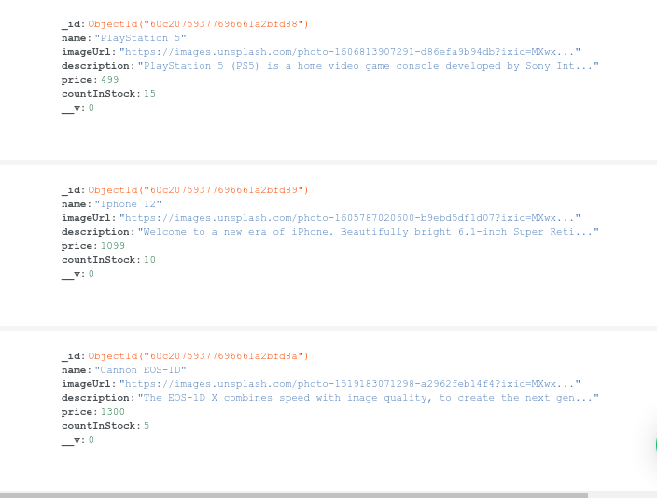

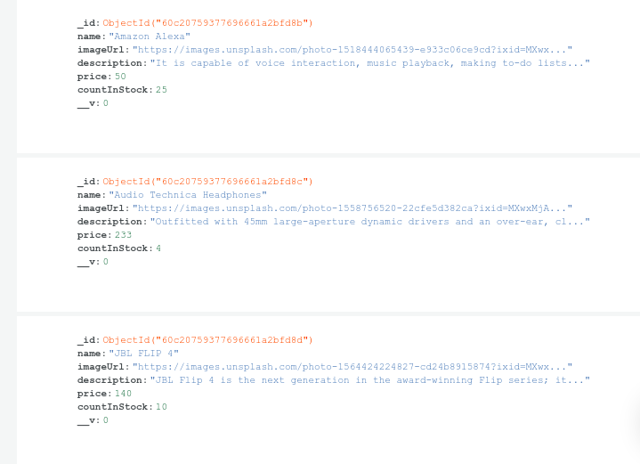

Home page:

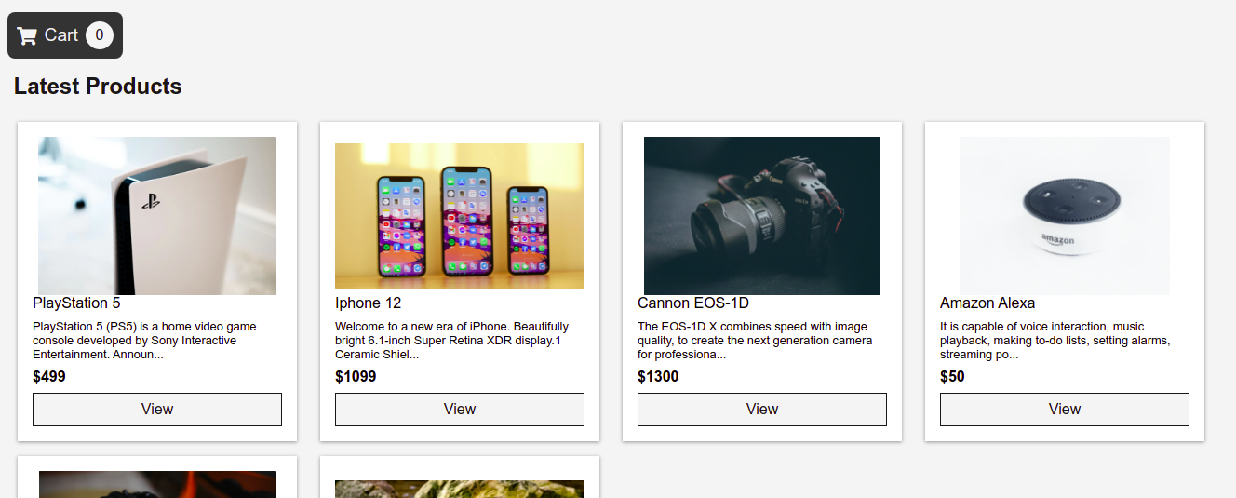

Others pages:

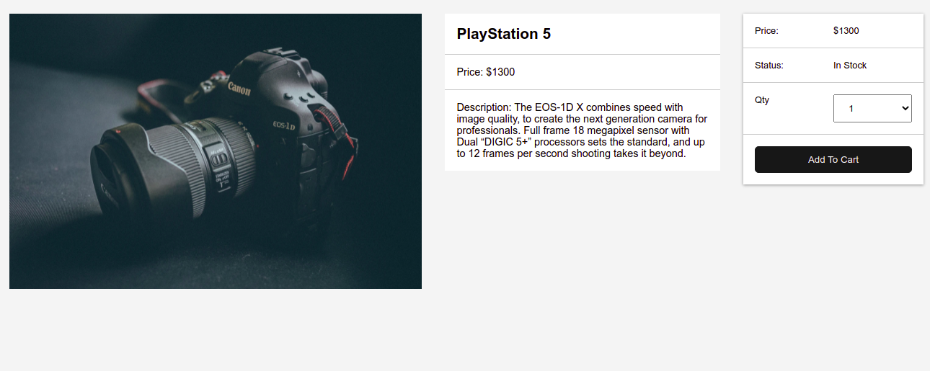

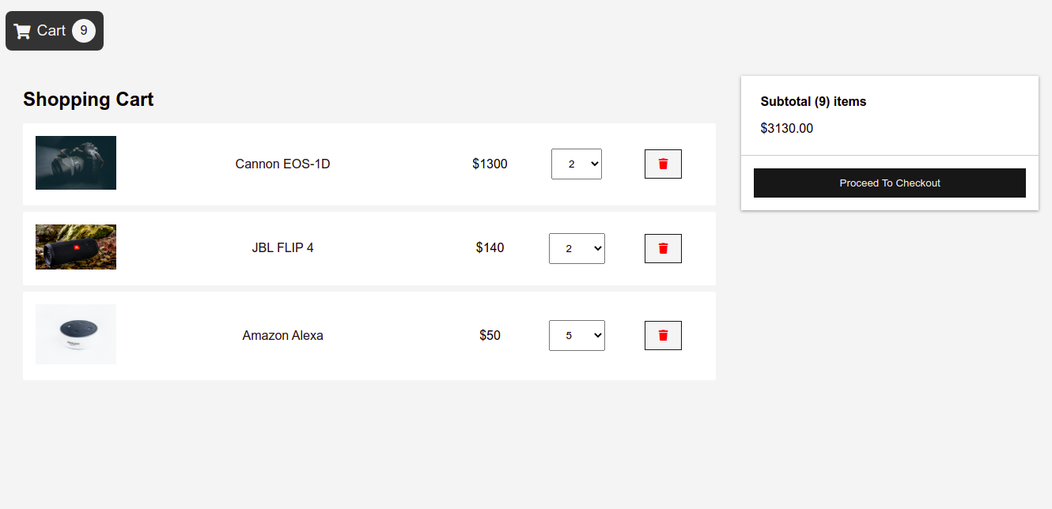

Future Goal

So far we have implemented only for WEB, haven’t use Flutter for mobile. Our goal is to do that also. And testing plan will include the white testing also.